Software Requirements Specification

for

Online consultation and appointment

**Prepared by**

**Surya Saveri Susarla**

**Savita Gunaki**

**Vaishnavi C**

**PES University, Bangalore**

**1st February 2021**

**Table of Contents**

**Table of Contents ii**

**Revision History ii**

**1. Introduction 1**

1.1 Purpose 1

1.2 Intended Audience and Reading Suggestions 1

1.3 Product Scope 1

1.4 References 1

**2. Overall Description 2**

2.1 Product Perspective 2

2.2 Product Functions 2

2.3 User Classes and Characteristics 2

2.4 Operating Environment 2

2.5 Design and Implementation Constraints 2

2.6 Assumptions and Dependencies 3

**3. External Interface Requirements 3**

3.1 User Interfaces 3

3.2 Software Interfaces 3

3.3 Communications Interfaces 3

**4. Analysis Models**

**5. Other Nonfunctional Requirements 4**

5.1 Performance Requirements 4

5.2 Safety Requirements 5

5.3 Security Requirements 5

5.4 Software Quality Attributes 5

5.5 Business Rules 5

**6. Other Requirements 5**

**Appendix A: Glossary 5**

**Appendix B: Field Layouts 5**

**Appendix C: Requirement Traceability matrix 6**

**Revision History**

|  |  |  |  |
| --- | --- | --- | --- |
| **Name** | **Date** | **Reason For Changes** | **Version** |
|  |  |  |  |
|  |  |  |  |

# Introduction

## Purpose

The purpose of this system is to provide a correct and complete description of the requirements for the software Online consultation and appointment (Practo). Our aim is to help patients book appointments online from the best doctors in and around the city. We have seen many problems arising when we have an increasing number of patients visiting a doctor thereby making it difficult to manage an appointment system manually. To solve this complication, we can have a custom built database software to manage the appointment system.

## Intended Audience

This system is implemented for all the individuals who want to get treated by the best practitioners in the city. The users can participate only if they have created an account through the registration form and have provided their medical history. Once they get registered themselves further they would not need to update their record as it would be done automatically after each doctor’s visit.

There are 3 basic users : Patient , Doctors and Admins.

1. All the users have their own profiles.
2. The webcam interaction between the doctor and the patient.
3. Patients can search for a doctor and make online appointments. They also can view their health record, lab reports, doctor’s prescription and medical expenses. Patients can also register complaints with any doctor.
4. Doctor’s can give appointments , e-prescription and can view patients' health records.
5. Admin views and manages the appointments and also he has authority to add/delete users, grant permission to doctors . He also views the complaints of patients and takes necessary actions.

## Product Scope

Healthcare is one of the most important and basic needs for any living being. But unfortunately in a country like India, billions of people struggle for a better healthcare. For those people, we are on a mission to provide health related services by allowing the users to book an appointment with the best Doctors around them.

The proposed system can make a huge impact on people’s lives as it enables solutions for most critical things i.e. health related problems in an easy and much convenient manner so that patients can easily get access to the doctor's profile and make online appointments.

The second purpose is to create an online medical history database so that doctors and patients can freely exchange patients' medical history information much easier, faster, and safer. There are many features in the proposed system which are unique and are public friendly.

## References

[1] Practo official site: <https://www.practo.com/>

[2] <https://www.docsity.com/en/online-doctor-appointment/2628556/>

[3] <https://ukdiss.com/examples/online-medical-appointment-booking-system.php>

# Overall Description

## Product Perspective

The online consultations and appointment is meant to serve as a common platform to the clients to book meetings with the specialists who are accessible in their adjacent areas. Since the application is facilitated in an online workspace it makes it simple for the clients to see the entire specialist’s profile and audits about the specialist to book arrangements in earlier on their telephones or PCs from their home or some other favored media, wiping out the need to visit the specialist’s place.

## Product Functions

**2.2.1 Context Diagram**

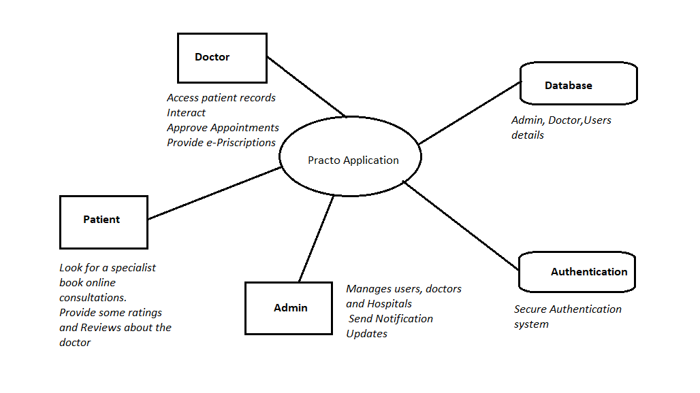

**2.2.2 Use Case Diagrams**

**2.2.2.1 Use case diagram for patient**

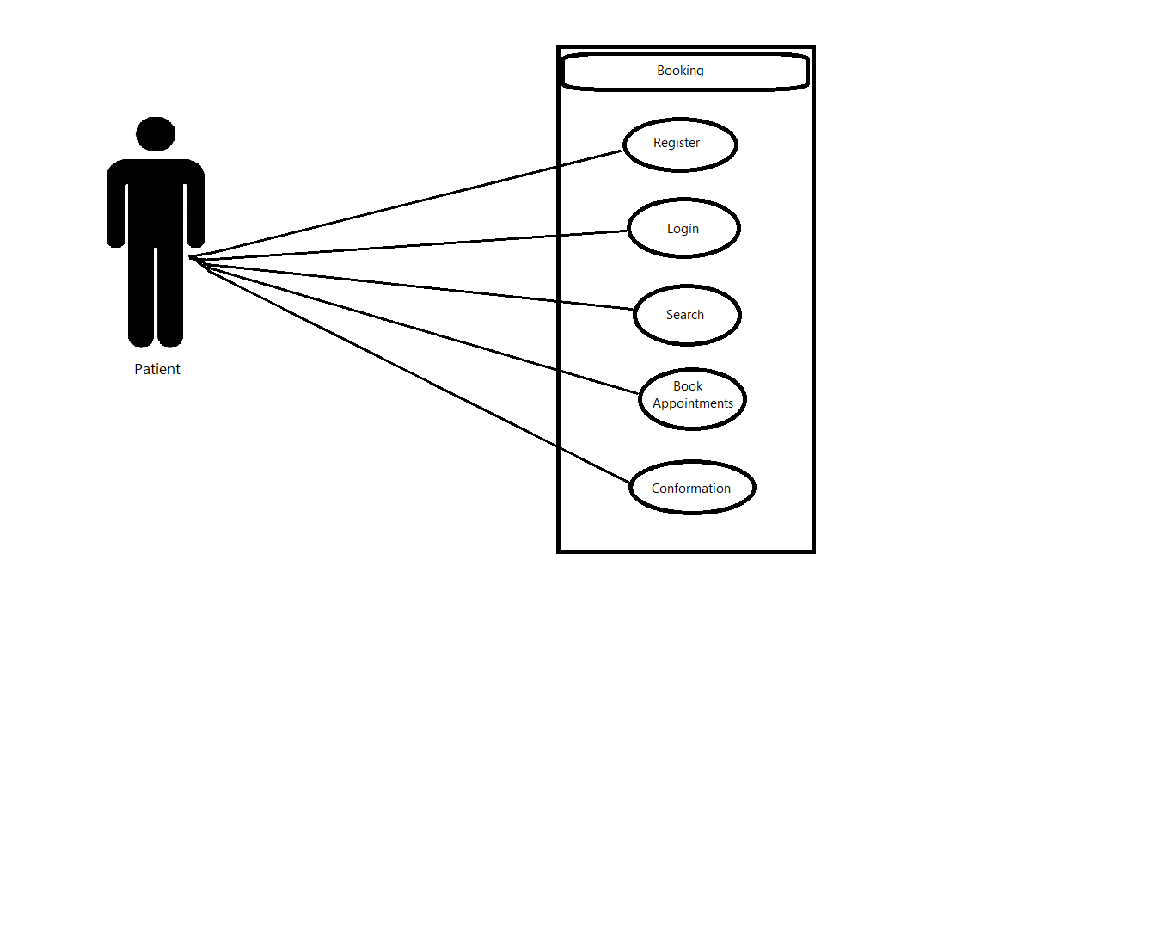

**2.2.2.2. Use case diagram for doctor**

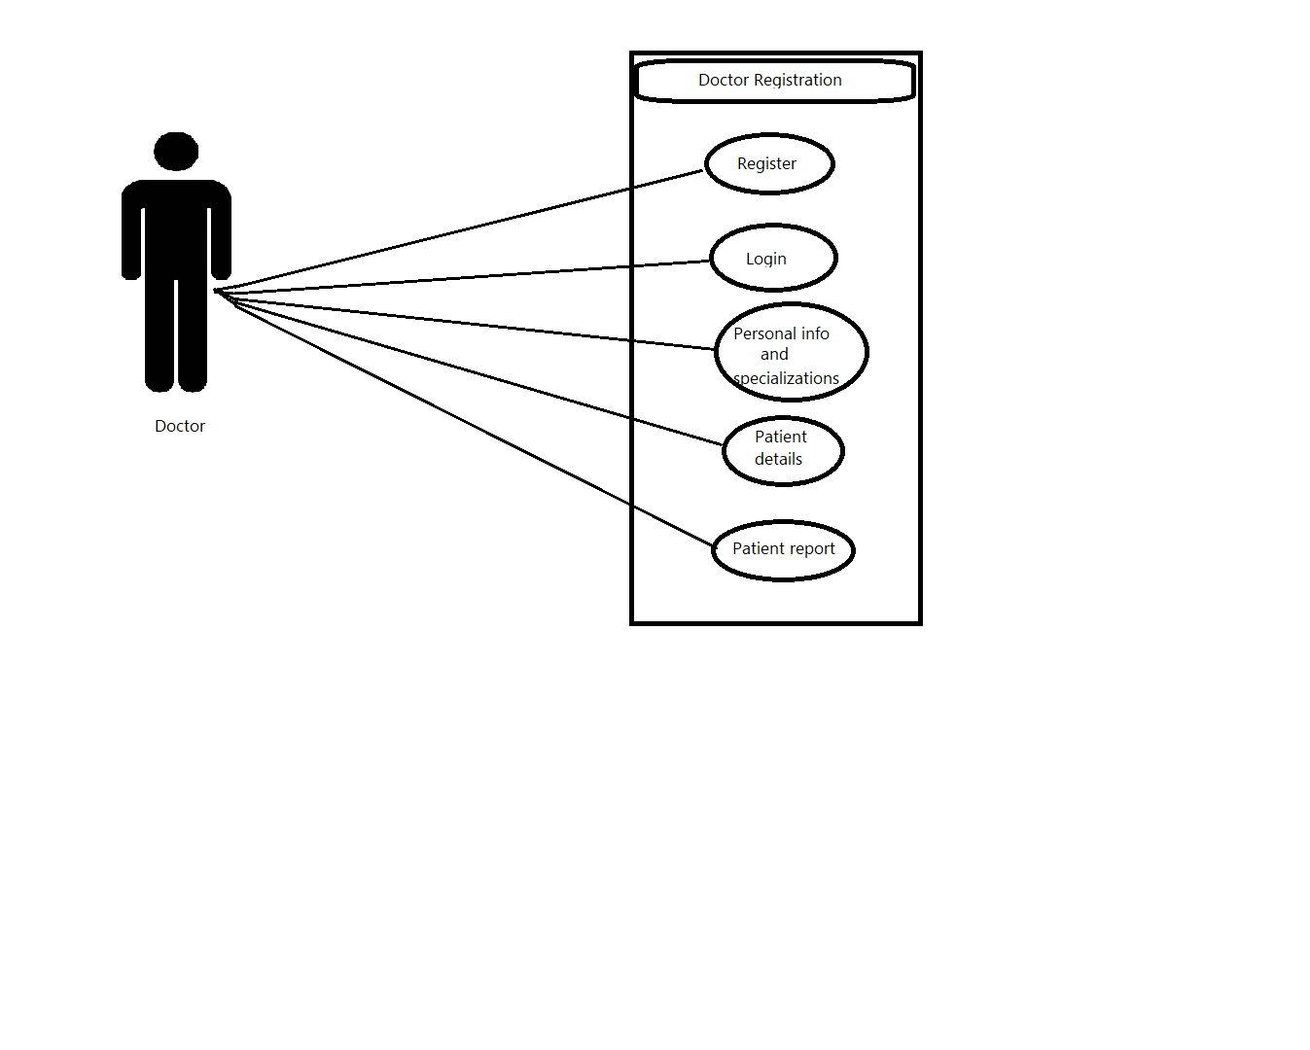

**2.2.2.3. Use case diagram for Admin**

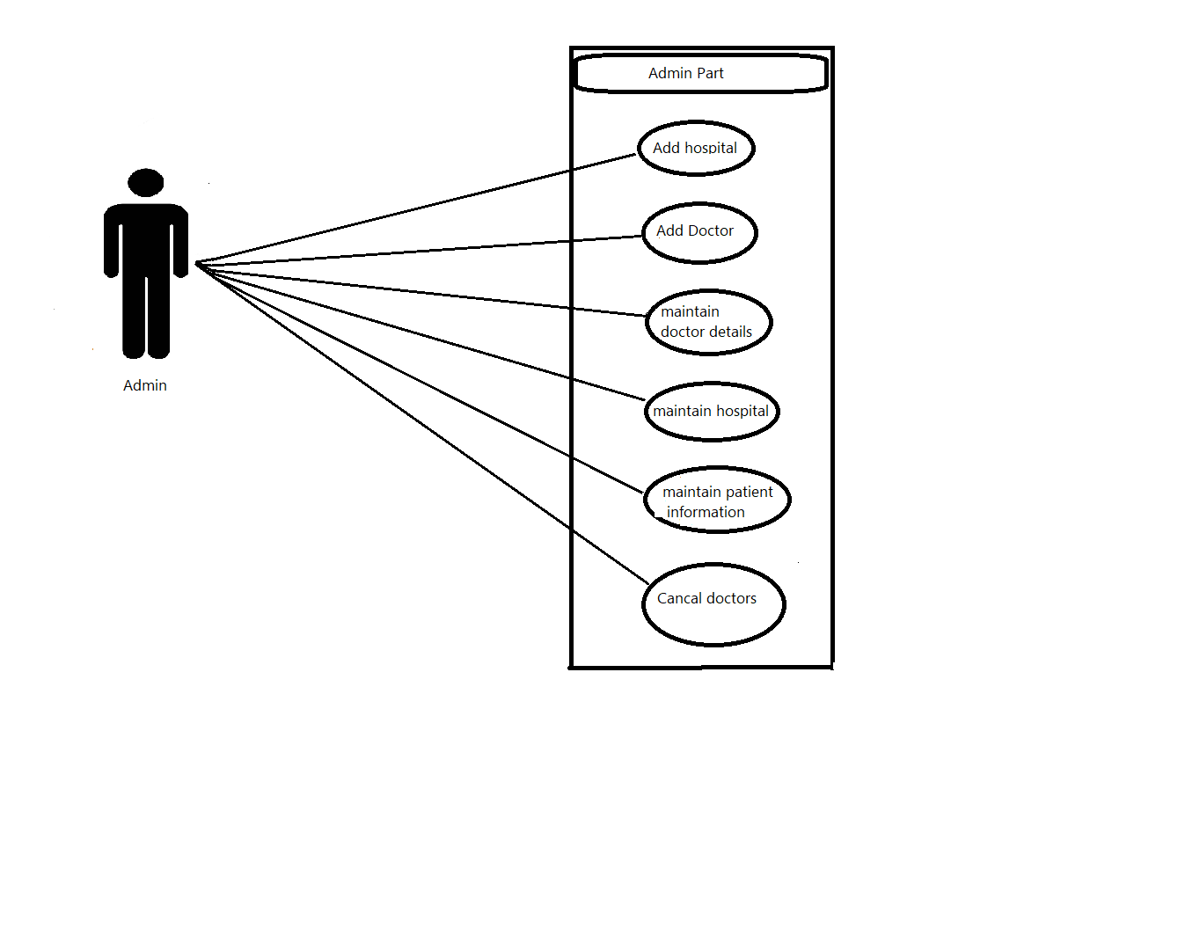

**2.2.2.4. Use case diagram for hospital**

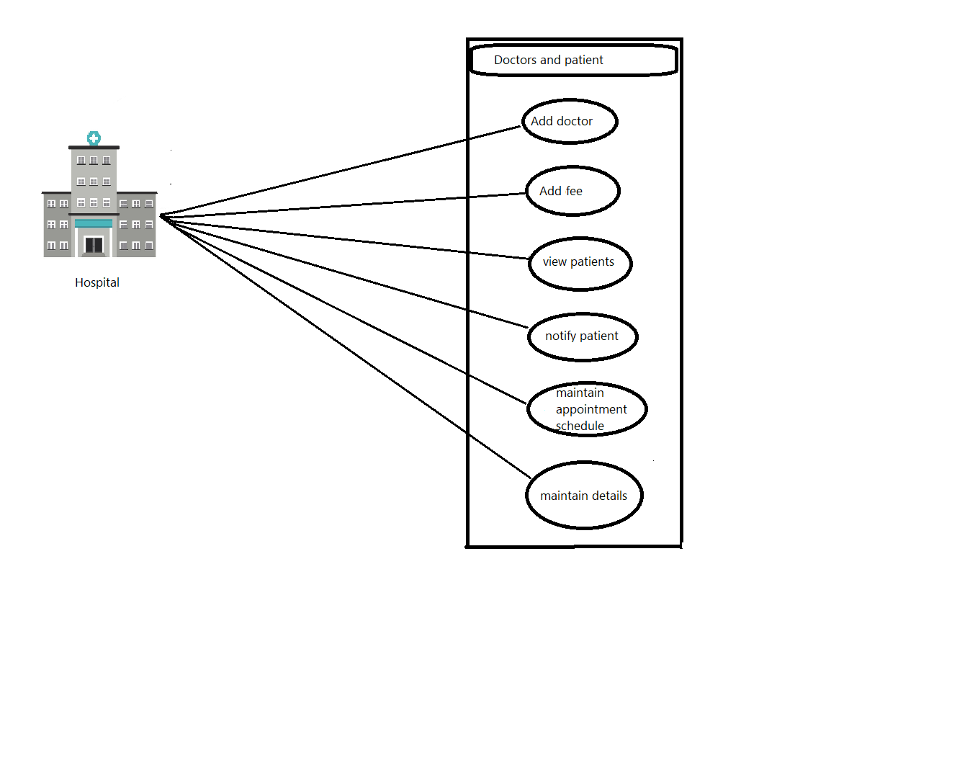

## User Classes and Characteristics

**2.3.1 Admin**

They can add new users and patients. Can display a specialist’s profile and points of interests, availability, ratings and reviews given by users and display healing centers which are close to the user. Admin also sends updates and notifications via email and SMS.

## 2.3.2 User

They are the primary consumers for this online consultation system. They can look for a specialist within their area of stay and their specialization. They will also get the recent updates about what is happening in the application. Users can also opt for online consultations from home. Users can decide on the specialist in light of the healing center of their own desire and get update messages about arrangements, reports etc..via sms and email. They can also rate the doctor and write some reviews about the doctor based on their experience with the doctor so that it will be beneficial for other users.

**2.3.3 Doctor**

Doctors can access the records of the patient. The doctor can also interact with the patients through online consultations , approve appointments and provide an e-prescription to the patient. The doctor can also interact with other specialists in the platform.

**2.3.4 Hospital**

The hospital can provide the specialists’ information and area of specialization, they can also update the doctor’s availability, accessibility, experience and their meeting charges.

## Operating Environment

The hardware and the software technology used should have the following specifications:

1. Ability to create new accounts for the users and doctors.
2. Ability to save the transactions and related information.
3. Ability to validate the users and the doctors.
4. Ability to recommend the users about the specialized doctors within their area.
5. Ability to book appointments for the patients.

## Design and Implementation Constraints

1. Design constraints:

* The communication between the portal software and the database will be done using SQL.
* The portal layout will be done using HTML/CSS/JavaScript
* The product can be written in PhP
* The source code must have coding conventions of PhP
* The System Administrators must have access to Comprehensive documentation

1. Software Constraints

The system will be intended to run on Firefox 4 and above, Google Chrome 10 and above and Internet Explorer 8 and above.

1. Software system attributes

* The Apache web server
* The PhP Application
* The MySQL database
* The database should remain consistent at all times in case of an error.

## 2.6 Assumptions and Dependencies

1. Each user must enter a valid username and password to login or register.
2. Privacy will be maintained.
3. In order to access the application server must be running.
4. Only the users who have logged in or registered can access the facilities.
5. Only the administrator will have the rights to modify or delete the information in the database.

# External Interface Requirements

## System Interfaces

Apache2 will be used as a web server. The user will input data via the web server using HTML forms. The actual program that will perform the operations is written in php.

## User Interfaces

The software provides an intuitive user interface such that all new users are able to search for doctors and book appointments and online consultations without any assistance. It must allow the administrator to easily add patient information, doctor’s information and hospital information or modify the information without any difficulties.

## Software Interfaces

1. Server Side

Apache will be used as a web server, accepting all the requests from the client and forwarding it accordingly. A database will be used centrally using MySQL.

1. Client Side

We will be using an OS(in our case windows) capable of running a modern browser which supports scripting languages like HTML,CSS,JavaScript and PhP.

## Communications Interfaces

The communications interface will be Windows. The HTTP / HTTP(s) will be used for the safer communications.

## Hardware Interfaces

1. Server Side

The application will be hosted on a web server which is listening to the web standard port using port 80

1. Client side
2. Monitor Screen: The software will display the information(such as user reviews, Doctor rating and profile etc..) via monitor screen.
3. Mouse: The software shall interact with the movement of the mouse and move the mouse buttons. The mouse shall activate areas of data input, command buttons and select options from menus.
4. Keyboard: The keyboard will input data into active area of the database.

# Analysis Models

ER Diagram

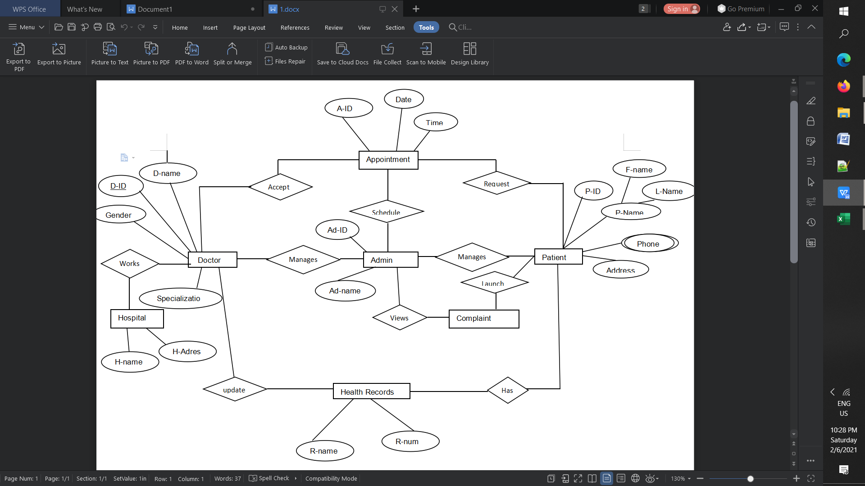

# Other Nonfunctional Requirements

## Performance Requirements

The system must be interactive and the delays involved must be less. So in every action-response of the system, there are no immediate delays. In case of opening of web pages, popping of the error messages and saving the settings or sessions there is delay much below 2 seconds. The system is easy to handle and navigates in the most expected way with no delays. Uninterrupted connections must be maintained.

## Safety Requirements

The system must be safe in all security aspects. The basic information should be kept safe in the databases. The login account must be always logged out as the person closes the website. The customer services must be available in case of any emergency. Must check for the proper authorization from time to time.

## Security Requirements

Any user who wants to access the software first has to login or register using Login ID and password. Any modifications in the database like inserting, deleting or updating of information can be quickly executed only by the administrator. Only the administrator can view and can alter any information. All the patient details will be secured.

## 5.4. Software Quality Attributes

Other software quality attributes that can be provided are:

**5.4.1 Availability**

The system must be available all the time for the end users. The internet has to be available whenever we want to access the software.

**5.4.2 Portability**

The application is Windows based and should be compatible with other systems. Apache, PhP and MySQL programs are practically independent of the OS-system which they communicate with.

**5.4.3 Security**

1. Passwords saved must be encrypted in the database to ensure user privacy
2. The user’s IP will be logged
3. The system will be protected against vulnerabilities such as SQL injection attacks

**5.4.4 Maintainability**

MySQL is used for maintaining the database and Apache web server takes care of the site.

## 5.5 Business Rules

These are the business rules drafted for online consultation and appointment system:

1. The website will take responsibility for failures due to hardware malfunctioning.
2. The warranty period of maintaining the software will be for one year.
3. In case of improper usage by the user no warranty can be provided.

# Other Requirements

**6.1 Database requirements**

The system must be able to use several data formats that are provided by the databases of different customers, clinics and hospitals. A transaction should have all the properties of a database transaction. The database transactions must be durable.

**Appendix A: Glossary**

USER: Or a Patient who is looking for the best doctor around them in the city to get the best medical advice there by helping them make better decisions about their health.

DOCTOR: A professional who treats a patient by solving the problems of a patient related to their health

ADMIN: A person who maintains the database and keeps track of all the users in the database and also notifies the user about the best doctors around them and their availability in which hospitals.

HOSPITAL: An institution providing medical and surgical treatment and nursing care for sick or injured people.

DATABASE: Place where the User’s, Doctor’s and Hospital’s details are stored.

**Appendix B: Field Layouts**

For the user table

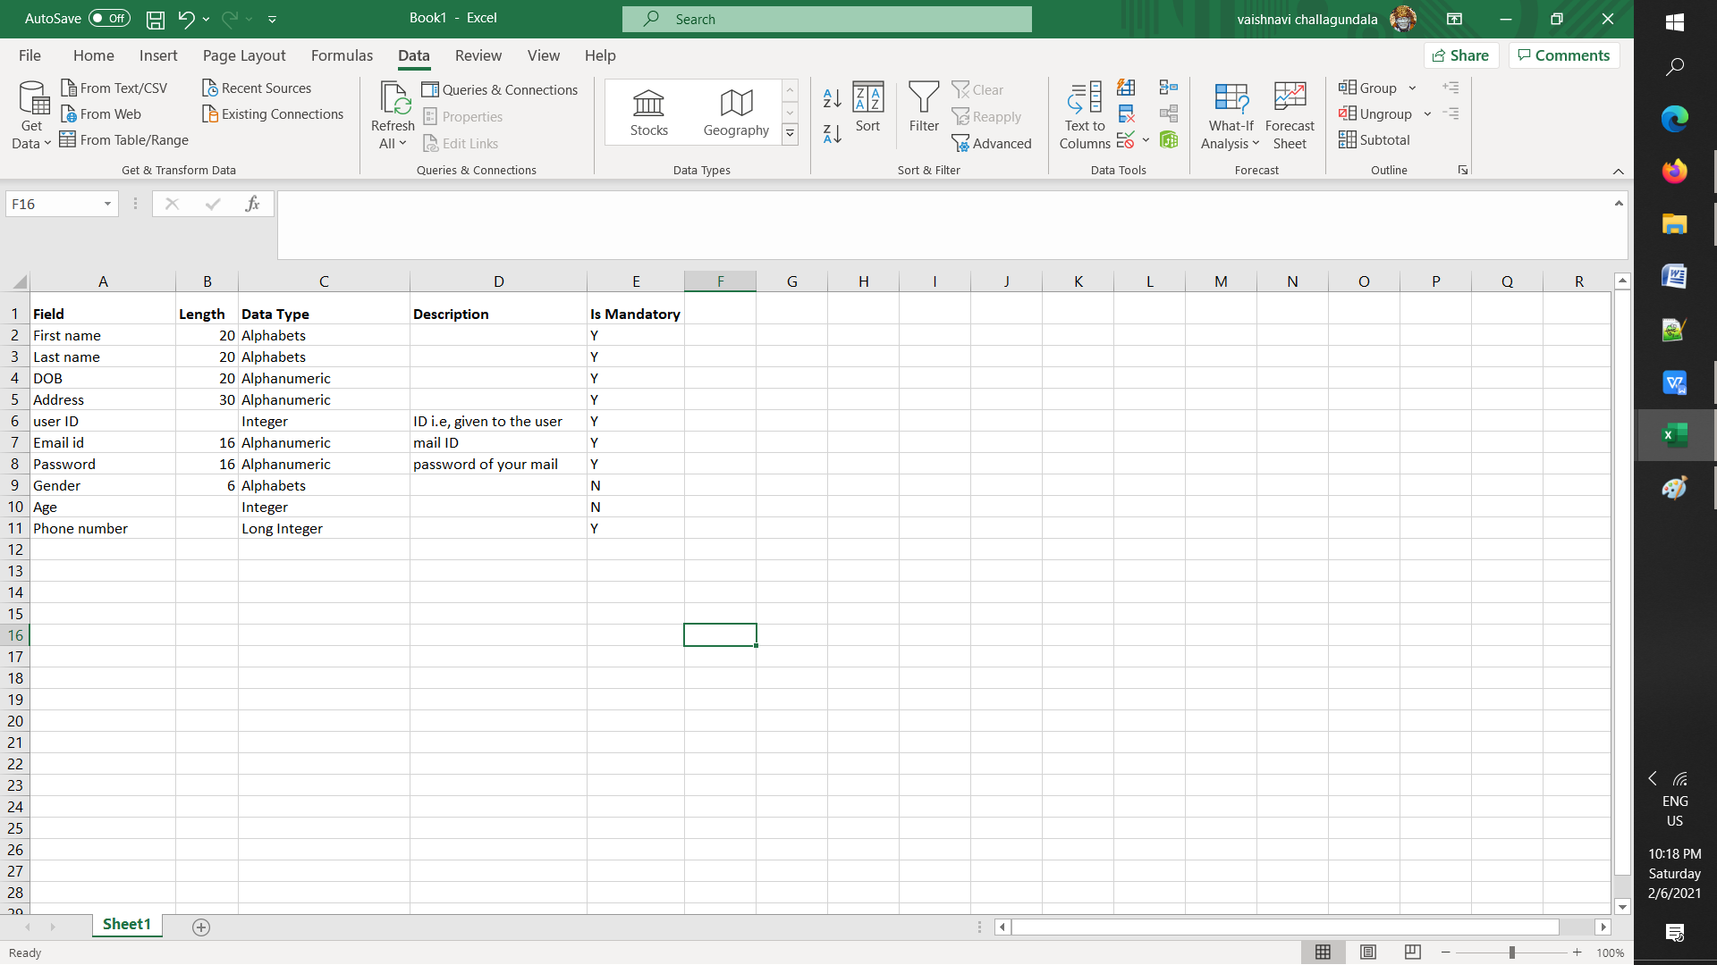

For the Doctor Table

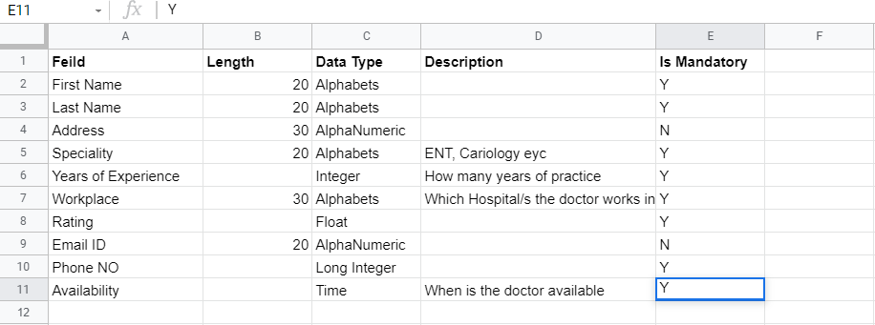

For the Admin Table

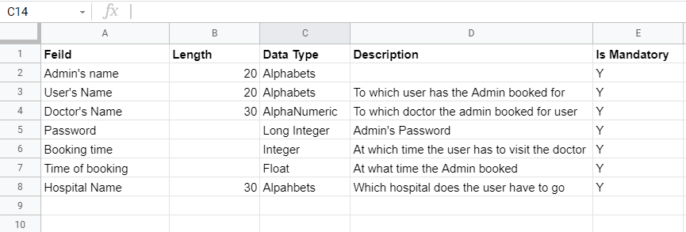

For Hospital Table

